Experiment name: Rotation in shape in opengl

Introduction: This project I make rotation shape in open gl.now let’s do this

Code:

#include <windows.h>

#include <iostream>

#include <stdlib.h>

#ifdef __APPLE__

#include <OpenGL/OpenGL.h>

#include <GLUT/glut.h>

#else

#include <GL/glut.h>

#endif

using namespace std;

//Called when a key is pressed

void handleKeypress(unsigned char key, int x, int y) {

switch (key) {

case 27: //Escape key

exit(0);

}

}

//Initializes 3D rendering

void initRendering() {

glEnable(GL_DEPTH_TEST);

glEnable(GL_COLOR_MATERIAL); //Enable color

glClearColor(0.7f, 0.9f, 1.0f, 1.0f); //Change the background to sky blue

}

//Called when the window is resized

void handleResize(int w, int h) {

glViewport(0, 0, w, h);

glMatrixMode(GL_PROJECTION);

glLoadIdentity();

gluPerspective(45.0, (double)w / (double)h, 1.0, 200.0);

}

float _angle = 30.0f;

float _cameraAngle = 0.0f;

//Draws the 3D scene

void drawScene() {

glClear(GL_COLOR_BUFFER_BIT | GL_DEPTH_BUFFER_BIT);

glMatrixMode(GL_MODELVIEW);

glLoadIdentity();

glRotatef(-_cameraAngle, 0.0f, 1.0f, 0.0f);

glTranslatef(0.0f, 0.0f, -5.0f);

glPushMatrix();

glTranslatef(0.0f, -1.0f, 0.0f);

glRotatef(_angle, 0.0f, 0.0f, -1.0f);

glBegin(GL_QUADS);

//Trapezoid

glColor3f(1.0f, 0.0f, 0.0f);

glVertex3f(-0.7f, -0.5f, 0.0f);

glVertex3f(0.7f, -0.5f, 0.0f);

glVertex3f(0.7f, 0.5f, 0.0f);

glVertex3f(-0.7f, 0.5f, 0.0f);

glEnd();

glPopMatrix();

glPushMatrix();

glTranslatef(1.0f, 1.0f, 0.0f);

glRotatef(_angle, 0.0f, 1.0f, 0.0f);

glScalef(0.7f, 0.7f, 0.7f);

glBegin(GL_TRIANGLES);

glColor3f(0.0f, 1.0f, 0.0f);

//Pentagon

glVertex3f(-0.5f, -0.5f, 0.0f);

glVertex3f(0.5f, -0.5f, 0.0f);

glVertex3f(-0.5f, 0.0f, 0.0f);

glVertex3f(-0.5f, 0.0f, 0.0f);

glVertex3f(0.5f, -0.5f, 0.0f);

glVertex3f(0.5f, 0.0f, 0.0f);

glVertex3f(-0.5f, 0.0f, 0.0f);

glVertex3f(0.5f, 0.0f, 0.0f);

glVertex3f(0.0f, 0.5f, 0.0f);

glEnd();

glPopMatrix();

glPushMatrix();

glTranslatef(-1.0f, 1.0f, 0.0f);

glRotatef(_angle, 1.0f, 0.0f, 0.0f);

glBegin(GL_TRIANGLES);

//Triangle

glColor3f(0.0f, 0.0f, 1.0f);

glVertex3f(0.5f, -0.5f, 0.0f);

glVertex3f(0.0f, 0.5f, 0.0f);

glVertex3f(-0.5f, -0.5f, 0.0f);

glEnd();

glPopMatrix();

glutSwapBuffers();

}

void update(int value) {

_angle += 2.0f;

if (_angle > 360) {

_angle -= 360;

}

glutPostRedisplay(); ////Tell GLUT that the scene has changed

glutTimerFunc(25, update, 0);

}

int main(int argc, char** argv) {

//Initialize GLUT

glutInit(&argc, argv);

glutInitDisplayMode(GLUT_DOUBLE | GLUT_RGB | GLUT_DEPTH);

glutInitWindowSize(400, 400);

//Create the window

glutCreateWindow("Color");

initRendering();

//Set handler functions

glutDisplayFunc(drawScene);

glutKeyboardFunc(handleKeypress);

glutReshapeFunc(handleResize);

glutTimerFunc(25, update, 0); //Add a timer

glutMainLoop();

return 0;

}

Output:

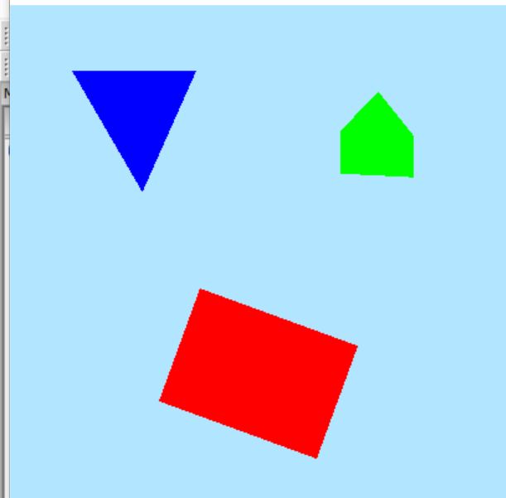

Conculation:this project use some function. Like glutInit(&argc, argv);glutInitDisplayMode(GLUT_DOUBLE | GLUT_RGB | GLUT_DEPTH);glutInitWindowSize(400, 400)and other function to make this shape.